Oyster Task Force Meeting
Tuesday, August 24, 2021, 1:00pm
New Orleans Lakefront Airport
6001 Stars and Stripes Blvd.
New Orleans, LA

I. Pledge of Allegiance
II. Roll call and introduction of guests

Voting Members Present:
Dan Coulon
Jakov Jurisic
Mitch Jurisich
Brad Robin
Brandt Lafrance
Al Sunseri
Sam Slavich
Peter Vujnovich
Willie Daisy

Voting Members Absent:
Shane Bagala
Tracy Collins
Byron Encalade
John Tesvich

Non-Voting Members Present:
Carolina Bourque via webinar
Justin Gremillion
Bryan Marie
Harry Vorhoff
Brian Lezina

Non-Voting Members Absent:
Karl Morgan

III. Al Sunseri motioned to approve the July 20, 2021 meeting minutes, 2nd by Peter Vujnovich. Motion carries.

Jakov Jurisic motioned to add an agenda item, To Discuss the Sandy Point Seasonal Pollution Line.
Motion withdrawn.

Al Sunseri Motion to approve the August 24, 2021 meeting agenda as presented, 2nd by Sam Slavich. Motion carries.

IV. Treasury Report
Remaining Fund Balance- $558,564
Remaining Budget Balance-$129,989

Peter Vujnovich motioned to approve the treasury report as presented, 2nd by Jakov Jurisic. Motion carries.

V. Committee Reports
- Public Private Oyster Seed Grounds Committee- no report
- Enforcement report- July 20-August 17, 2021
Region 4
Iberia-no report

Region 5
Cameron-no report
Calcasieu-no report
Vermillion-no report

Region 6
Terrebonne
19 – fail to complete trip tickets (dealer)
19 – fail to complete trip tickets (fishermen)

Lafourche
2 – take oysters from an unapproved area (polluted) drone used to make case
1 – violate sanitary code (refrigeration) drone used to locate vessels.
10 – sacks of oysters returned to water

Region 8
Plaquemines
3-Unlawfully Take Oysters From State Water Bottoms
2-Violate Sanitary Code (Log Book)
1-Violate Sanitary Code (Refrigeration)
36 Sacks of Oysters Seized

St Bernard
2-Violate Sanitary Code (Refrigeration)
1-Violate Sanitary Code (Log Book)
70 Sacks of Oysters Seized

Jakov Jurisic expressed concern with the temperature requirements in coolers on oyster boats; Request for Item for next meeting regarding temp requirements from LDWF and LDH

Brad Robin asked if a presentation can be made at the next task force meeting to clarify how the trip ticket should be filled out and signed

Jakov Jurisic motioned to write a letter to LDWF enforcement to request that enforcement stops enforcing this rule until further clarification is made. Motion does not carry due to no 2nd to the motion

Al Sunseri suggest hosting a training session to inform and refresh everyone on the current regulations and laws

Mitch Jurisich requested that the task force have trip tickets in front of them at the next meeting and give a small presentation at the next meeting

C. Legislative Committee- no report
D. Legal Committee- no report
E. Research Committee- no report
F. Coastal Restoration Committee- no report

G. Marketing Committee- BMF- content developed and created for August and September for website, just need to fact check, social can be launched in the next week or so if everything can get approved and fact checked in time, if anyone is still interested in giving info please reach out; hope to have more by the next meeting

H. Health Report-
Justin Gremillion stated that Sept/ Oct a new classification period is coming out, some new changes based on

Ronnie Connair stated that a new classification for area 8 is needed, currently using historical data how can we get LDH to take new samples

Justin Gremillion stated that too many storms to get more samples, have to get five samples in the area in order for it to be classified and were not able to do that with the storms. Were keeping the areas open without sampling so decided to close the area to keep from getting dinged from the FDA. Since there is concern going to go ahead and reopen the area so that they can get the 5 sample classifications. Going to do the best they can, given that storm season is coming going to try and get samples but if the weather is bad may need to close again if they can’t get samples

I. Aquaculture- LA Sea Grant is building more information to the website, if anyone is interested in an aquaculture grant they should contact Earl Melancon

Members appointed to the grant committee Peter Vujnovich, Faye Matthews and Brandi Shelley as an alternate

Dr. Lea asking for support for application for LDWF for a demo permit to demo the shellevator in grand Isle, in the process of getting the permit, will bring the shellevator to a pier at the entrance of Grand Isle and demonstrate for anyone who is interested to operate it as an oyster nursery. Wants to demonstrate what the gear can provide and will report it back to the OTF and will help make a good decision on the policy, asking for OTF to support his pursuit of receiving a permit from LDWF for a demo permit

Al Sunseri motioned to support the Shellevator demo project so long as La Department of Health and LDWF approve the project, 2nd by Brandt Lafrance. Motion carries.

Carolina Bourque stated that LDWF needs to get with LDH to discuss this permit further

Brandi Shelley requested a future agenda item to discuss where can and can’t buy seed from and who and where moving forward

J. Joint Task Force Working Group- no report

VI. New Business
- The task force heard the oyster stock assessment results and the 2021/22 oyster season recommendations
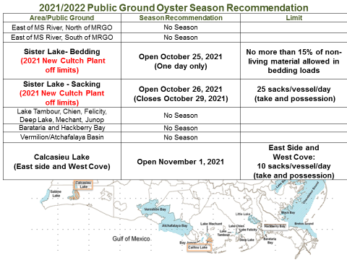
Brad Robin motioned to support LDWF’s 2021 Oyster Season recommendations, 2nd by Dan Coulon. Motion carries.
- Carolina Bourque provided a presentation on an oyster season recommendation regarding a temporary natural reef in Lake Barre
Marsh creation project in Lake Barre area that plans to transport sediment from the area designated as a borrow site: the designation of the Lake Barre Temporary Natural Reef is needed to allow harvest of any and all oyster resources before borrowing activities begin; This Natural Reef Creation was requested direct by the oyster industry; R.S.56:434: allows the Commission to designate natural reefs within the state and to set aside state water bottoms for the planting, growth, propagation, and policing of seed oysters for the use of the oyster industry; Due to the overall declining availability of oyster resources on the public oyster seed grounds, the lack of available state-owned water bottoms for oyster leasing. Area is about 1200 acres.
Proposed Temporary Season
- Opening Monday, October 11, 2021
- Closing Friday, October 22, 2021
- Bedding only
- the 15% living material rule will not be enforced on the temporary public grounds in Lake Barre but will be enforced during the bedding season elsewhere in the state.

Proposed Designated Area
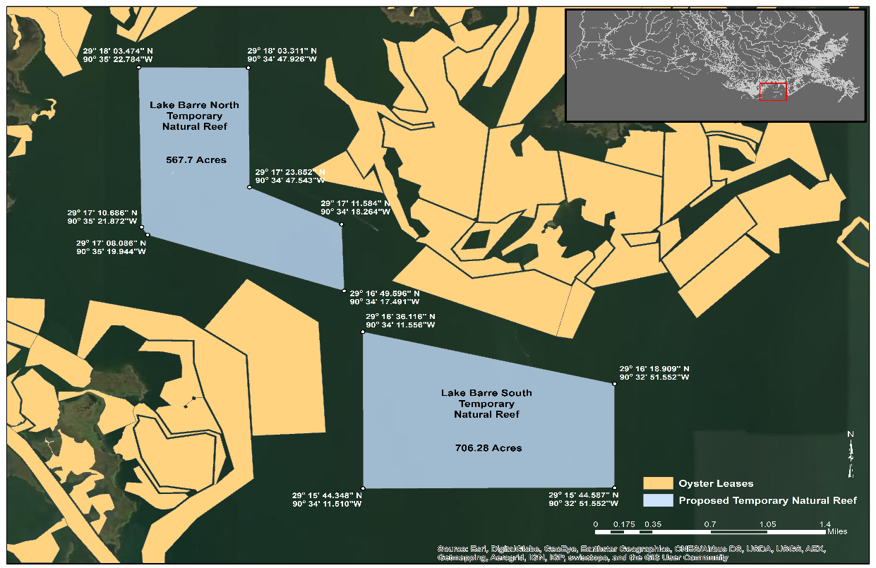
Dan Coulon motioned to support LDWF’s temporary opening of oyster season in Lake Barre, 2nd by Brandt Lafrance. Motion carries, with 1 abstained- Al Sunseri.
- Brian Lezina provided an annual update on planned coastal restoration and protection activities
2017 Coastal Master Plan- TOTAL PROJECTED EXPENDITURES: $887 MILLION
●Planning
●Engineering & Design
●Construction
●Operation, Maintenance & Monitoring
●Ongoing Programs & Initiatives
●Operating Costs
Current Projects:
- Bayou De Cade Ridge and Marsh Creation
- Caminada Back Barrier
- Rabbit Island Restoration- dredging
- Grand Bayou Flood Gate
- West Grand Terre Beach Nourishment and Stabilization
- Terrebonne Basin Barrier Island
- Barataria Basin Ridge and Marsh Creation
- Golden Triangle Marsh Creation
- Monitoring
- Planning Activities- Updates to Oyster Resource Zones, provide for update based on current conditions, discuss potential future conditions, describe oyster zones based on farming method will be presenting further to gather fisher input, Other work to better site oyster restoration projects
Upcoming Projects:
- Lake Borgne Marsh Creation
- Large Scale Barataria Marsh Creation
- Biloxi Marsh Living Shoreline
- Mid-Barataria Sediment Diversion
- Grand Chenier Ridge Marsh Creation
- Mid-Breton Landbridge Marsh Creation and Terracing
- New Orleans Landbridge
- Terrebonne Ridge and Marsh Creation
- Houma Nav Canal Lock Complex
Other Projects and Activities:
- NRDA RP 5 Oyster Projects
- Updated future projections from 2023 Master Plan
- CWPPRA Project Construction lacoast.gov
- Structural Projects

Tony Citanovich barrier island project issue with narrowing gaps 6-7,000ft wide
- Laura Picariello led discussion on a sustainability resolution in support of sustainability certification
Marine Stewardship Council (MSC)- certified oyster on private leases in LA and TX
Certification with conditions- conditions must be met to maintain certification
Conditions include:
Precautionary approach in management
External review of the management system

Proposed Sustainability Resolution- (LDWF Commission)
- Modeled off the resolution utilized in the certification of Louisiana blue crab
  - Generalized to cover all fisheries, not specific
- Resolution including language demonstrating use of precautionary approach in management decision-making
- More direct language to demonstrate what LDWF already does – precaution to keep stock at sustainable levels and management actions to rebuild stock when thresholds are reached
- Industry support needed to bring before Louisiana Wildlife and Fisheries Commission

Mitch Jurisich stated that the oyster industry is different from crab and shrimp, in that a lot of production from the private sector. The industry is pretty good managers when it comes to sustainability; don’t think we can support at this time but maybe at some point in the future
Sam Slavich stated that the one term that scares him is shell currency; shell budget
Al Sunseri stated that this is not an industry that has to deal with imports and you have private sector that does a great job on sustainability
Brad Robin motioned to not support the proposed sustainability resolution, 2nd by Brandt LaFrance. Motion carries.
- Laura Picariello led discussion on an external review of LA management in support of sustainability certification
External Review:
- MSC requires the management system undergo periodic review by an external body
- Review to include elements such as data collection, decision-making, responsiveness to stakeholder concerns, enforcement and compliance
- Two proposals received- from independent contractors
- Funded, but opportunity for participation/feedback within the review

- The task force discussed a cooperative endeavor agreement between LDWF and Plaquemines Parish regarding the closure of Mardi Gras Pass
Would like to reestablish the CEA agreement between LDWF and Plaquemines Parish regarding the closure of Mardi Gras Pass, what’s the remaining balance and is something still owed? Believe he is asking for an additional $50K remaining balance of $43K
The CEA ended on January 1, 2019, LDWF has made three payments to Plaquemines Parish and it was a total of approximately $157K so the unspent amount was $43K and some change, would like to potentially use the funds left over to compensate the permitting process for the emergency closure and maybe to begin the bidding process
Brian Lezina stated that CPRA is not opposed to a rehabilitation of the structure
The task force wants to make sure everything is in place to move forward pending the acceptance of the permit
Duncan Kemp stated that currently LDWF can negotiate the CEA and construction costs
- The task force considered a new contract for the hiring of Joe Piacun for OTF legal counsel
Did not receive the new contract so will take up this item at a later date; will get Joe Piacun to forward new contract
- The task force considered funding for the 2022 LA Alive event and associated
Brad Robin motioned to set a cap of 30K to fund the OTF’s participation in the 2022 LA Alive event, the purchase of oysters, beads, and board member travel, 2nd Dan Coulon. Motion carries
VII. Public Comment
Jack Isaacs stated this this spring the legislature asked LDWF to come up with an assessment of what happens to oyster shells, how much is shipped out of state/ kept in state. LDWF developed a short questionnaire and will call some of the larger dealers in the state to help understand the flow of oyster shells in and out of the system, hopefully sometime soon there will be some results that can be brought to the task force; Also, today LDWF put a link leading to survey about sea trout management options and you opinions and results at the next commission meeting
Jakov Jurisic stated that Sam Slavich plans to step down from the appeals board, asked Willie Daisy to nominate somebody to the review board; need email need to have a public seed ground permit to serve on the board
VIII. Next meeting set for Tuesday, September 28, 2022 for 1pm in St. Bernard at the New Orleans Lakefront Airport
IX. Motion to adjourn by Jakov 2nd by Brandt Lafrance. Motion carries.

